Lab – Demonstrate Spreadsheet Limitations in

1. Objectives

Observe the limitations of a spreadsheet when it is used for data analysis.

Part 1: Explore and Download the Data

Part 2: Determine the Root Bridge

1. Background / Scenario

There are massive amounts of open data available on the Internet for you to download and use to perform analysis. In this lab, you will explore the limitations of spreadsheets in data analysis using an open dataset from the City of Seattle.

1. Required Resources

* PC device with high-speed Internet access
* Spreadsheet program, such as Microsoft Excel, Google Sheet, LibreOffice Calc, Apple Numbers, or OpenOffice Calc

1. Explore and Download the Data

In this part, you will download the dataset *Road Weather Information Stations* from <https://data.seattle.gov>. You will also explore some of the characteristics of this dataset.

* + 1. Navigate to <https://data.seattle.gov/Transportation/Road-Weather-Information-Stations/egc4-d24i?>.
    2. Click **View Data**.

This dataset lists the road and air temperatures from the sensors embedded on bridges and surface streets within the city limits of Seattle. The data is updated every fifteen minutes.

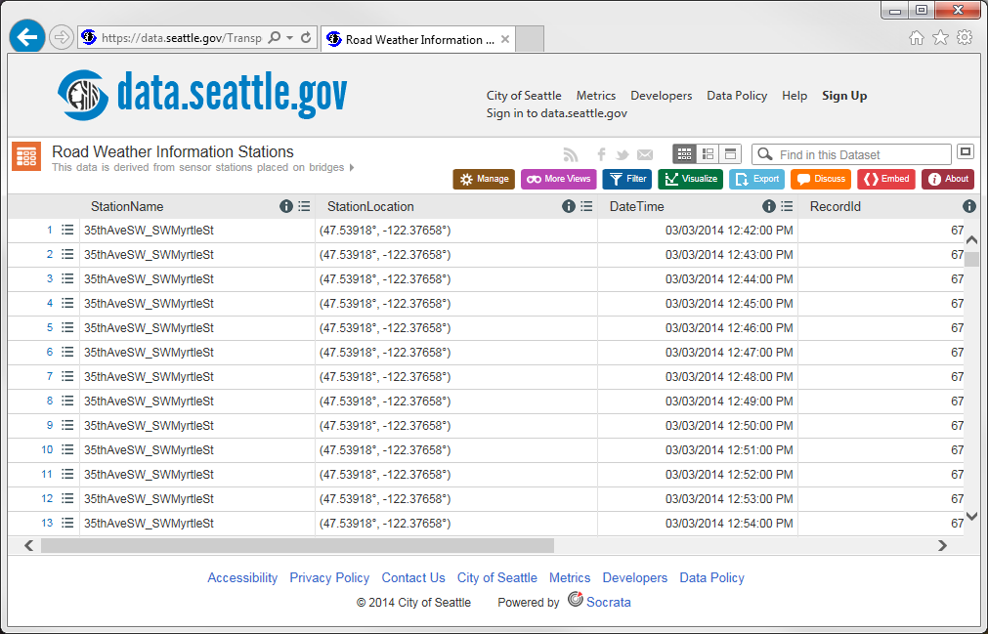

How many fields (columns) are in the dataset? How many records (rows)?

____________________________________________________________________________________

What are the field names?

____________________________________________________________________________________

* + 1. Click **Export**. Click **CSV** to download this dataset as CSV. The download will take a few minutes. If you are unable to download the file, continue to the next part.

**Note**: If you were unable to completely download the file, *Road_Weather_Information_Stations.csv*, search for *Road_Weather_Information_Stations.csv.part* in your file system. It is mostly in your Download folder. Change the filename to *Road_Weather_Information_Stations.csv*.

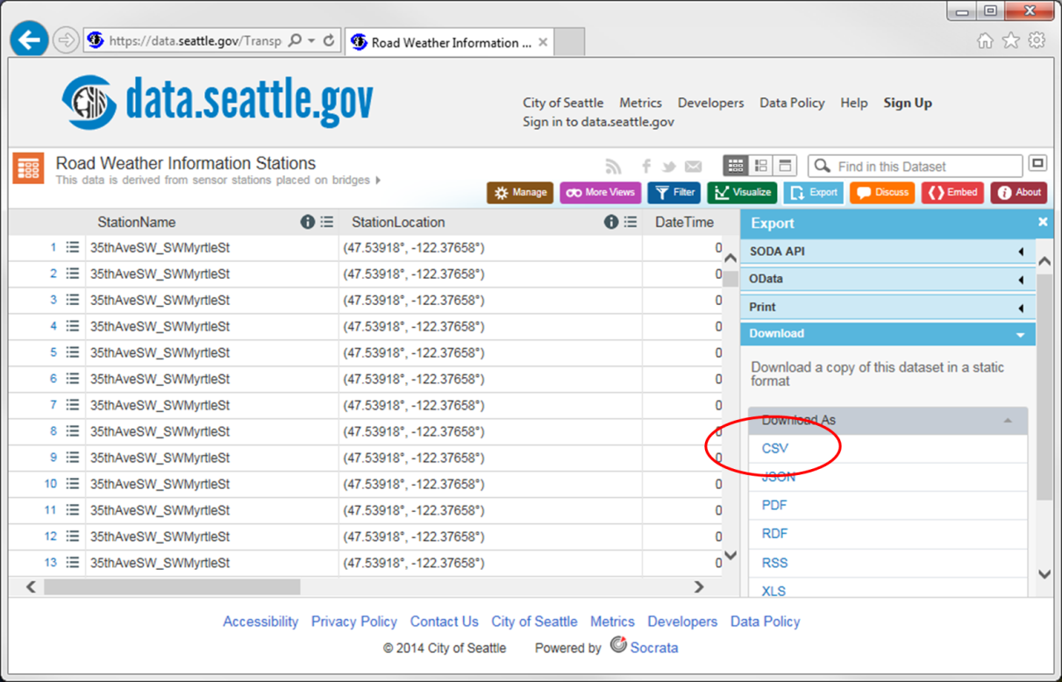

What is the size of the downloaded file? ________________________________________

1. Explore the Limitations of a Spreadsheet

With the downloaded dataset, you will attempt to open it in the spreadsheet program of your choice. If you were unable to download the file, you can review the steps and explore the limitations of spreadsheets without opening the file in a spreadsheet program.

* + 1. Open your spreadsheet program. Microsoft Excel is used in this example.
    2. Import the downloaded csv file, Road_Weather_Information_Stations.csv. Click the **Get External Data**. Click **From Text** and choose *Road_Weather_Information_Stations.csv.*

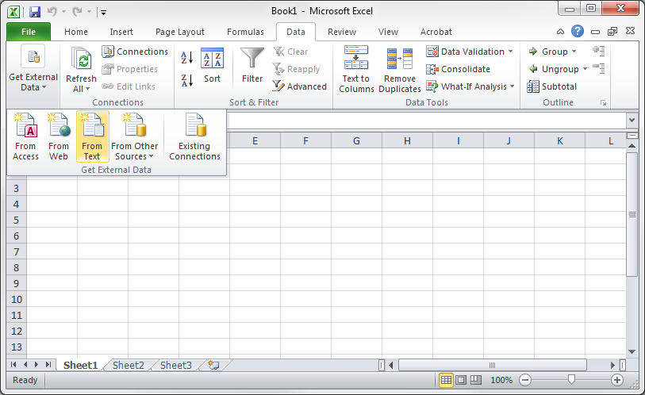

* + 1. The Text Import Wizard displays. In step 1 of 3, click **Next** to continue.

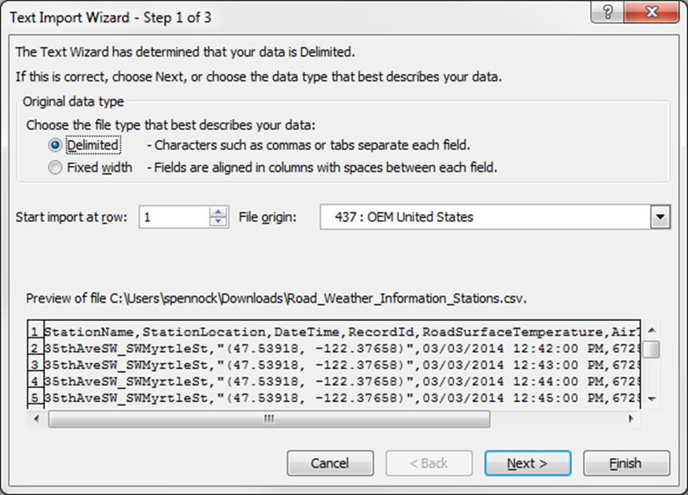

* + 1. In step 2 of 3, select **Comma** as the delimiter and unselect **Tab**. Click **Next** to continue.

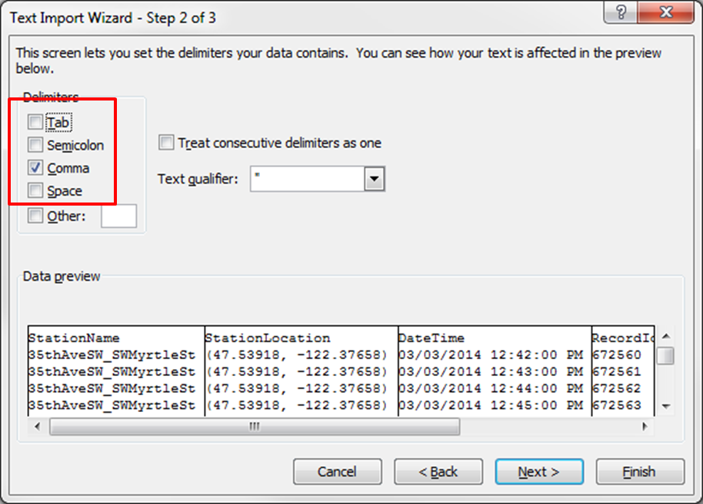

* + 1. In step 3 of 3, click **Finish** to continue.

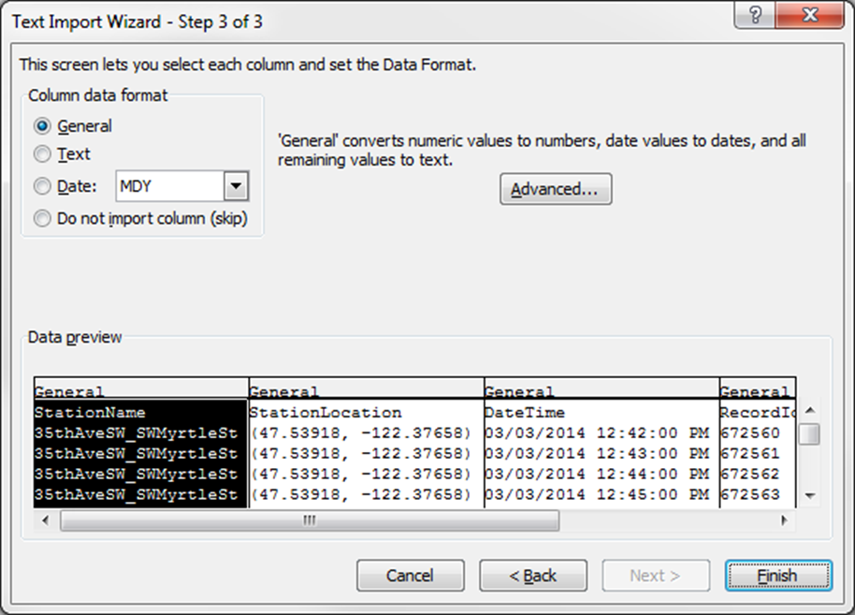

* + 1. Click **OK** to import the data.

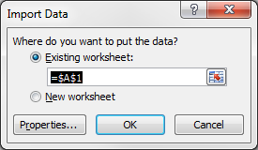

What is the warning message you received?

____________________________________________________________________________________

____________________________________________________________________________________

____________________________________________________________________________________

____________________________________________________________________________________

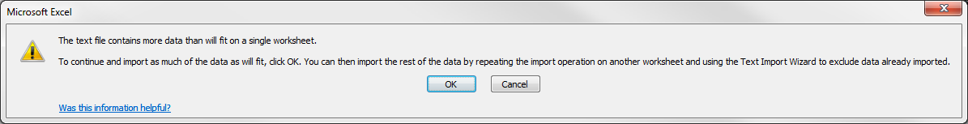

How will this limitation impede your analysis of the data?

____________________________________________________________________________________

____________________________________________________________________________________

* + 1. Open a new spreadsheet. Try to reach the maximum number of rows in the spreadsheet. What is the maximum number of rows in the spreadsheet of your choice?

____________________________________________________________________________________

Compare the maximum number of rows in the spreadsheet to the number of records in the Road Weather Information Stations dataset from <https://data.seattle.gov>. Using this observation, explain the limitation of the spreadsheet.

____________________________________________________________________________________

____________________________________________________________________________________

1. Reflection

If the popular spreadsheet programs cannot handle larger data sets, what data analysis tools are available? Use the Internet to search for some possible tools.

_______________________________________________________________________________________

_______________________________________________________________________________________